**WeSketch**

A shared white board built for University of Illinois at Springfield CSC 478B group project by Team Infinity.

**Project Lead:** Jeremy Westbrook

**Programmer Lead:** Aras Vitkus

**Test Lead:** Vance Dhooge

**Table of Contents:**

**Quick Start Web Links:**

* **[User Manual](http://downloads.teaminfinityuis.com/WSDownloads/WeSketch_User_Manual.docx)**
* **[Installer](http://downloads.teaminfinityuis.com/WSDownloads/WeSketchInstaller.zip)**
* **[Source](https://github.com/pindr0p/WeSketch)**

**1 Project Plan:**

1.1 Scope Statement

1.2 Tools and Standards

1.3 Organizational Chart

1.4 Gantt Chart

1.5 Configuration Management Plan

**2 Programmers Manual:**

2.1 Requirements Documentation

2.2 Project Requirements

2.3 Architecture Diagrams

2.4 Data Diagram

**3 Testing Documentation:**

3.1 Black Box Tests

3.2 Unit Tests

**4 Known Issues:**

**1 Project Plan**

**1.1 Scope Statement**

Whiteboards are a common tool used when collaborating with multiple individuals. We are going to create a Windows based desktop application that removes the physical limitation of a whiteboard. The application will be developed with a client server relationship. The clients will be Windows based with special attention given to Windows 7 compatibility. The server will be IIS hosted web services and databases. The clients will communicate to the server in two ways. The first is through a restful web services for prompted tasks such as logging in or inviting a user to your whiteboard or joining another whiteboard. The second form of communication is for passive real time data through web sockets using SignalR. This data will be generated by a user drawing on the board, coordinates will be sent to the server which will in turn forward that data to all other connected clients. Data retention will last as long as a member of the group exists on the whiteboard. When a new user joins the whiteboard, a client will automatically send data to the new client which will populate the new client’s whiteboard.

**1.2 Tools and Standards**

**Programming Language:** C#

**IDE:** Visual Studio 2017

**Source Control:** Git via github.com

**Project Management:** Wrike.com

**Documentation:** Guidelines found [here](https://bb.uis.edu/bbcswebdav/pid-1058192-dt-content-rid-6486087_1/courses/173CSC47812329/Group%20Project/Project%20Deliverables/deliverables.html).

**Code Standards:**

* Coding standards will follow the asp.net web stack coding conventions found [here](http://aspnetwebstack.codeplex.com/wikipage?title=CodingConventions).

**EXAMPLES:**

Variables are pascal case, methods and namespaces are camel case.

private int myInt =1;

private void MyMethod()

Class Variables prepended with an _

private object _myObject = new object();

Var should only be used when it is obvious what the type is.

**Bad**: var mysteryObject = _myObject.MysteryProperty;

**Good**: var myString = “MY STRING”;

var myObject = new object();

* Bracing and indentation will follow the allman style found [here](https://en.wikipedia.org/wiki/Indent_style#Allman_style).

**EXAMPLE:**

All children code lines are indented inside the parent bracing. Bracing is used even when it is optional(such as with if statements).

public class Example

{

public bool Data()

{

if(1 == 1)

{

return true;

}

return false;

}

}

* The Visual Studio extension StyleCop will be used to enforce standards. StyleCop can be found [here](https://stylecop.codeplex.com/).

**Commenting:**

* Every class should have at least summary tag. Type /// above the class and it will be automatically generated. You should give a brief description of the class.

**Example:**

///<summary>

///This class is useless and has no purpose.

///</summary>

public class Useless

* Every method should have at least summary and an explanation of each parameter by using param. The layout can be automatically generated by typing /// above a method.

**Example:**

///<summary>

///This method is useless and shouldn’t be used.

///</summary>

///<param name=”param1”>This makes the useless method more useless.</param>

public void UselessMethod(int param1)

* Commenting in methods should only be used when you feel they are necessary. If you feel you need to leave a comment inside of a method then try to create a new method and leave a summary for the new method. If that isn’t possible then feel free to leave your comment.

**Server:**

* Rest API for prompted requests.
* SignalR for real time data sent to clients.
* SQL database to manage users.
* Windows Server 2012.
* IIS web server.

**Client:**

* WPF for GUI.
* SignalR requests and inputs for real time server communication.
* Rest API requests for prompted communication.

**1.3 Organizational Chart**

**Team Structure:** Democratic Centralized

We are using the Democratic Centralized team structure. This will allow everyone the opportunity for input to reach a decision democratically. However, it will also give the project lead discretion to make decisions in the interest of time should the need arise.



**1.4 Gantt Chart**

Also viewable [here](https://i.imgur.com/ABebWDx.png).

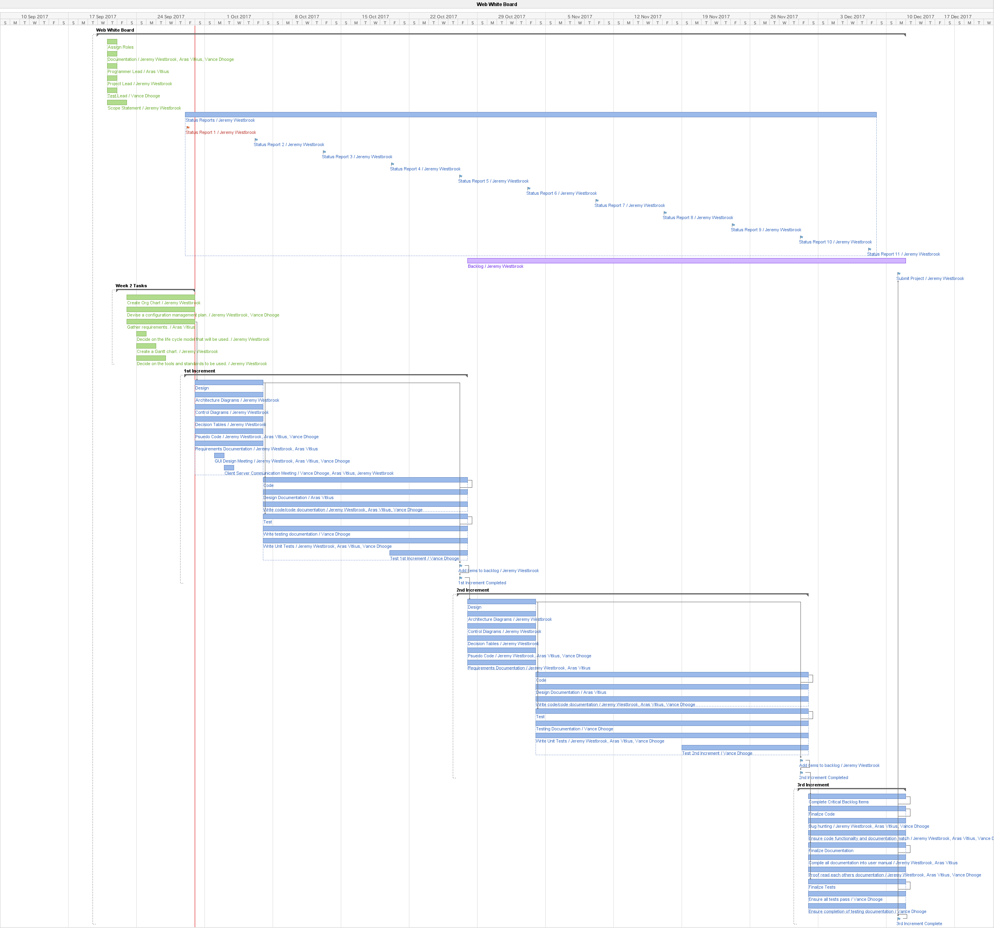

**1.5 Configuration Management Plan**

* Versioning Format {Major}.{Minor}.{Build} Major increases with a version release. Minor increases with a feature release. Build increases after every build(i.e. changes made directly to the dev branch to patch something).
* Master branch is populated by a pull request containing all completed features at the end of an increment.
* Dev branch is populated by pull requests that have been approved by a peer.
* Peer review process will not be overly comprehensive and very informal. Functionality and completeness of the code is the responsibility of the programmer. The review should be a quick scan of the documents to look for convention and proper commenting errors.
* Everyone is assigned a build buddy. I send to Aras, Aras sends to Vance and Vance sends to me. In the event your build buddy isnít available then move to the next person. It is your responsibility to keep the team apprised of your availability.



**2 Programmers Manual**

**2.1 Requirements Documentation**

**Product Perspective:**

A business, company or any group of people might want a web white board to quickly share creative ideas in a simple manner. This kind of connection will allow users to enjoy recreational or professional creative freedoms with each other. This software is an all-in-one application that once installed users can interact with each other. A manager of a company can quickly share notes with their team and vice versa.

**Product Functions:**

The user will be able to connect to our server with the application. They can connect with other users at the same time. They will be able to draw on a white board with others online, making it similar to a real life white board in an office. This convenience allows users to stay at their computer instead of having to migrate to an actual white board. User will be able to draw on the canvas with each other in real time. Lines and shapes can be drawn on the white board canvas to get ideas across.

**User Characteristics:**

End-users will be anyone who wants to use the application. The application can be used by anyone.



**2.2 Project Requirements**

**1.0.x:** Users will be able to login with or register a user. User passwords are stored using a SHA 256 algorithm and not stored as plain text. A salt will be computed at the time a user is registered. There will also be a pepper stored on the server. Users passwords will authenticate with the combination of a dynamic password, a dynamic salt and a static pepper. The algorithm will generate a unique hash only possible by entering the correct password.

**1.1.x:** Users will be able to draw on the board. Board drawing info will be stored on the board owner’s pc. The board owner will send drawing information to users as they join. Strokes are sent to all users connected to the board.

**1.2.x:** Users connected to a board will be retained and shared by the board owner. As users connect to the board all connected users will be shared with new users. Likewise, when a new user connects to a board, there are added as a connected user to all users connected to the board.

**1.3.x:** Users will be able to change the size and color of their marker. This information will be sent when a user draws on the board.

**1.4.x:** Users will be able to erase a stroke. The board owner will be able to kick a user from a board.

**1.5.x:** Unit tests completed.

**2.3 Architecture Diagrams**

**1.0.x/1.3.x:**

WeSketchSecurity.cs , Login.Xaml.cs, WeSketchRestRequests.cs



WeSketchSecurity.cs , Register.Xaml.cs, WeSketchRestRequests.cs



**1.1.x/1.2.x:**

WeSketchApp.Xaml.cs, WeSketchSignalRClient.cs, WeSketchSignalRHub.cs



This diagram also reflects how connected users are shared. However rather than stroke info being requested and sent it would be connected user info.



**1.4.x:**

WeSketchApp.Xaml.cs, WeSketchSignalRClient.cs, WeSketchSignalRHub.cs



**2.4 Data Diagram**



**User Table:**

* **UserID** – A unique identifier assigned to the user upon registration. This unique id is used send individual messages to the user.
* **UserName –** This is the username that the user picks in the registration form.
* **Password –** The hashed password that the user created.
* **SeaSalt –** The salt that is generated when the user registers.
* **Email –** The email the user assigns when registering.
* **Disabled –** Signifies that the user account is disabled.
* **LastLoginAttempt –** When the user last tried to log in.
* **LastLogin –** When the user last successfully logged in.

**UserBoard Table:**

* **UserID –** The unique identifier for the owner of the board. Has a 1 to 1 relationship to User.UserID
* **BoardID –** The unique identifier representing the board. This id is used to send messaged to all users connected to the board.
* **BoardOwner –** A bit field signifying that a user is the owner of the board.
* **CanSketch –** A bit field signifying that a user can sketch on the board.

**3 Testing Documentation**

**3.1 Black Box Tests(Double click image to open.)**



**3.2 Unit Tests(Double click image to open.)**



**4 Known Issues**

* No way to get back to login page once you click on register button.
* When a board owner leaves a board other users can potentially be left in the board. When a board owner rejoins their own board they do not currently see anyone who is connected. They may receive updates from users that they don’t know are connected.
* Drawing outside of the bounds of the board will grow the board.